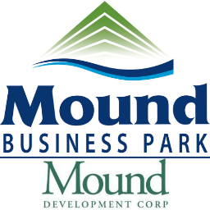

REGULAR BOARD MEETING AGENDA OF JULY 26, 2024, AT 8:00 A.M.

Roll Call

Approval of Minutes of the Regular Meeting of March 2024

CITIZEN FORUM

A CITIZEN DESIRING TO SPEAK ON AN ITEM, WHICH IS NOT ON THE AGENDA, MAY DO SO UNDER CITIZEN FORUM. DISCUSSION IS LIMITED TO FIVE MINUTES AND BOARD MAY NOT TAKE IMMEDIATE ACTION. HOWEVER, ITEMS INTRODUCED UNDER CITIZEN FORUM MAY BECOME AGENDA ITEMS FOR LATER MEETINGS.

Presentation(s)

Old Business

Current Business

- Financial Review
- Park Update / New Office Center
- Museum / Mound Connector Discussion-Follow-up
- Prospecting Update/ Fornes Contract Renewal

Study Session (if applicable)

Executive Session (if applicable)

Adjournment

